|  |  |
| --- | --- |
|  | **FPT ACADEMY INTERNATIONAL**  **FPT – APTECH COMPUTER EDUCATION** |

**Centre Name: ACE-THUDUC-1-FPT.**

**Address: 590 Cach Mang Thang 8, District 3, Ho Chi Minh City, Viet Nam.**

**FESTIVAL**

|  |  |  |
| --- | --- | --- |
| **Supervisor.** | Mr. Nguyen Phat Tai | |
| **Batch.** | T1.2306.M0 | |
| **Group.** | Group 5 | |
| **Serial No.** | **Enrollment Number** | **Student Name** |
| 1. | Student1477476 | Nguyen Thai Bao |
| 2. | Student1470290 | Nguyen Hoang Minh |
| 3. | Student1477201 | Le Trung Hoang |
| 4. | Student1470278 | Huynh Nguyen Than Phong |

Month 09 Year 2023

**This is to certify that**

**Mr.:**

Nguyen Thai Bao

Nguyen Hoang Minh

Le Trung Hoang

Huynh Nguyen Than Phong

**has successfully designed & developed**

eProject: Festival

**Submitted by: Le Trung Hoang**

**Date of issue: 16-Oct-2023**

**Authorized Signature: Hoang**

**TABLE OF CONTENTS**

ACKNOWLEDGEMENT 3

SYNOPSIS 3

PROBLEM DEFINITION 3

CUSTOMER'S REQUIREMENTS SPECIFICATIONS (CRS) 3

Business/Project Objective: 3

Hardware/ Software Requirements: 4

SCOPE OF THE WORK (IN BRIEF) 5

Architecture and design of the system 5

Diagram of the website 7

TASK SHEET REVIEW 1 8

SITE MAP 9

MOCK OF THE WEBSITE 9

**1.** **HOMEPAGE** 10

**2.** **CATOLOGIES** 10

**3.** **STORE** 11

**4.** **GALLERY** 11

**5.** **CONTACT US** 12

**6.** **ABOUT US** 12

TASK SHEET REVIEW 2 13

Website Description 14

**1.** **HOMEPAGE** 14

**2.** **CATOLOGIES** 15

**3.** **GALLEYRIES** 16

**4.** **STORE** 16

**5.** **CONTACT US** 17

**5.** **ABOUT US** 18

TASK SHEET REVIEW 3 20

# ACKNOWLEDGEMENT

*For the acknowledgement of the assignment, we would like to express our gratitude to the FPT – APTEC program for building and delivering practical programs allowing us to have the opportunities for the developments of our career path.*

*Secondary, we would like to thanks each of our team-members for spending time and effort in order to fulfill the requirements of the projects.*

*Finally, we would like to express our sincerest appreciation to Mr. Nguyen Phat Tai for his dedication supporting us throughout the project.*

# SYNOPSIS

*The Festivals.com is an informational website which is aim to provide detail information regarding to the religional festivals around the world.*

*The objectives of the website are:*

* *The function of the website is a travel blog website, which provides information and experiences about the famous festivals around the word.*
* *The additional products are the traveling and residence services.*
* *Provide reviews for the experiences and recommendations for the trips.*

# PROBLEM DEFINITION

The Web site is to be created based on the following requirements.

1. The Home Page should be created making use of Sections with a suitable logo
2. The site should display a menu which will contain the options for brief introduction about the various categories or link, and about is feedback and so on.
3. Links of the all the religion can be added and each religion link must open the list of the festivals coming under them.
4. The images of each festival must be added.
5. Navigation of the project must be made smooth and uniformity must be expected.
6. Various books based on the festivals must be added in the webpage, which user can see and purchase (for purchasing section the dummy procedure must be used).
7. Site map, Gallery, About us, Queries link, Contact us link must be added. Address of the Company should be displayed using GeoLocation API (eg. GoogleMaps).
8. The complete historic reason and its description must be allowed to get download as pdf or doc file.

# CUSTOMER'S REQUIREMENTS SPECIFICATIONS (CRS)

**Client: FESTIVAL**

### Business/Project Objective:

The Objective of this program is to give a sample project to work on real life projects. These applications help you build a larger more robust application.

The objective is not to teach you JavaScript/Dreamweaver but to provide you with a real life scenario and help you create basic applications using the tools.

You can revise the chapters before you start with the project.

This project is meant for students who have completed the module of ***HTML5.*** These programs should be done in the Lab sessions with assistance of the faculty if required.

It is very essential that a student has a clear understanding of the subject. Students should go through the project and solve the assignments as per requirements given.

Kindly get back @ [eprojects@aptech.ac.in](mailto:eprojects@aptech.ac.in) in case of any doubts regarding the application or its objectives.

**Input to the system:**

* + - * Browsing products based on brands, type of appliances..

**Output from the system:**

* A menu that will categorize all the functions of the site.
* Display the list of available albums category wisely.
* Perform the brief comparison by showing 2 products of the same type with their details.
* Site should be able to provide brief introduction/history about the company under About Us page.
* The location of the company is in Contact Us page.
* Besides the above requirements, the site should have look and feel as per the industry standards.

**Expected delivery date:** 16-Oct-2023..

**List of deliverables:**

* + - * Document Word.
      * User Guide.
      * Source code.

### Hardware/ Software Requirements:

**Hardware**

* + A minimum computer system that will help you access all the tools in the courses is a Pentium 166 or better.
  + 64 Megabytes of RAM or better.

**Software**

* + Notepad/HTML editor.
  + Dreamweaver, VisualStudioCode.
  + IE 5.0/ Netscape 6.0.

# SCOPE OF THE WORK (IN BRIEF)

**The team has discussed and has agreed about the website layout as shown briefly below:**

1. **Homepage**: Showing brief introduction about the company , introduction to festival around the world and type of products that it is selling. Furthermore, there are additional information such as:
2. **Catologies**: Containing its festival with their details and images categorized by type.
3. **Store**:Sell all festival-related products , including book and jewelry ,….
4. **Gallery :** Containing all images of all festival
5. **Contact Us**: Showing the contact information of the company such as address, location map, mobile, fax, email.
6. **About Us**: Introducing the history, archievements and further information about the company.

# Architecture and design of the system

# Diagram of the website



# TASK SHEET REVIEW 1

|  |  |  |  |  |  |  |  |
| --- | --- | --- | --- | --- | --- | --- | --- |
| **Project Ref. No.:**  **eP/Advertisement Portal Management**  **System/01** | | **Project Title:** | **Activity Plan Prepared By:** | **Date of Preparation of Activity Plan:** | | | |
| **Sr.**  **No.** | **Task** | **Actual**  **Start Date** | **Actual Days** | **Team**  **Mate Names** | **Status** |
| 1 | Problem Statement | Festival | Hoang | 16-Sep-2023 | 1 | Hoang,Minh,Bao,Phong | Completed |
| 2 | Analysis of the requirements about the website | 16-Sep-2023 | 1 | Hoang,Minh,Bao,Phong | Completed |
| 3 | The scope of the work (in brief) | 16-Sep-2023 | 1 | Hoang,Minh,Bao,Phong | Completed |
| 4 | Architecture and design of the system | 16-Sep-2023 | 1 | Hoang,Minh,Bao,Phong | Completed |
| 5 | Diagram of the website | 16-Sep-2023 | 1 | Hoang,Minh,Bao,Phong | Completed |
| 6 | Task Sheet | 16-Sep-2023 | 1 | Hoang | Completed |

|  |  |
| --- | --- |
| **Date: 22/09/2023** | |
| Signature of Instructor:  **Mr. Nguyen Phat Tai** | Signature of Team Leader:    **Mr.Le Trung Hoang** |

# 

# MOCK OF THE WEBSITE

Site map

1. **HOMEPAGE**
2. **CATOLOGIES**

**3.STORE**

**5.** GALLERY

**6. CONTACT US**

**7.ABOUT US**

# TASK SHEET REVIEW 2

|  |  |  |  |  |  |  |  |
| --- | --- | --- | --- | --- | --- | --- | --- |
| **Project Ref. No.:**  **eP/Advertisement**  **Portal Management System/01** | | **Project Title:** | **Activity Plan Prepared By:** | **Date of Preparation of Activity Plan:** | | | |
| **Sr.**  **No.** | **Task** | **Actual**  **Start Date** | **Actual Days** | **Team**  **Mate Names** | **Status** |
| 1 | Site map | Festival | Hoang | 29-Sep-2023 | 1 | Bao | Completed |
| 2 | Mock of the website | 29-Sep-2023 | 1 | Hoang,Minh,  Bảo | Completed |
| 3 | Task Sheet | 29-Sep-2023 | 1 | Hoang | Completed |

# 

# 

# WEBSITE DESCRIPTION

1. **Homepage**

The homepage contains the following information:

* + - * The name and navigation menu of the website.
      * The search bar.
      * The slideshows of the website gallery.

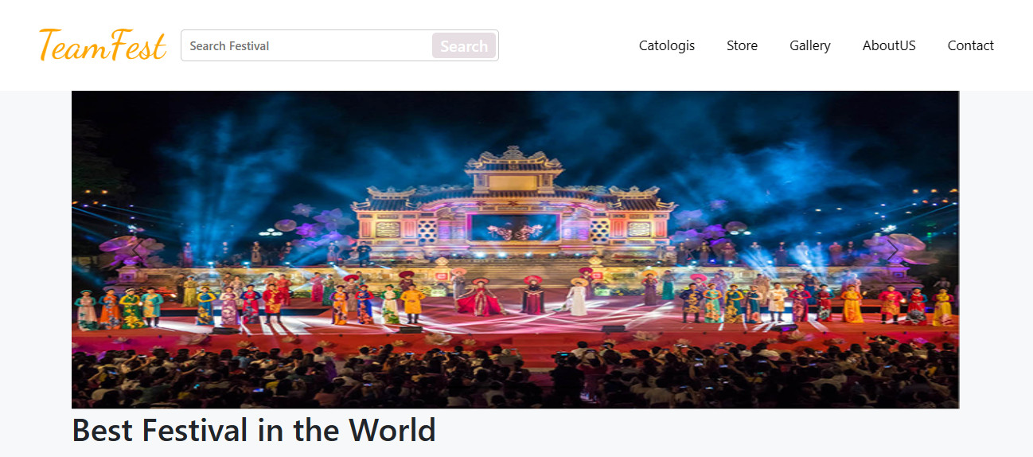

**The screenshot of homepage**

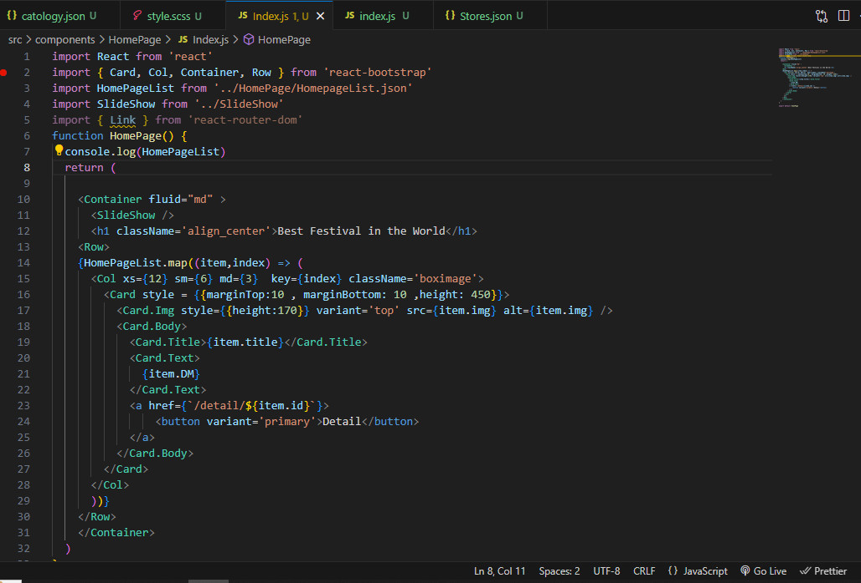

**Code of homepage**

1. **Categories**

The category shows the information of the festival themes. The customers and visitors can choose the interesting festival theme according to the personal taste and find the information regarding to the theme.

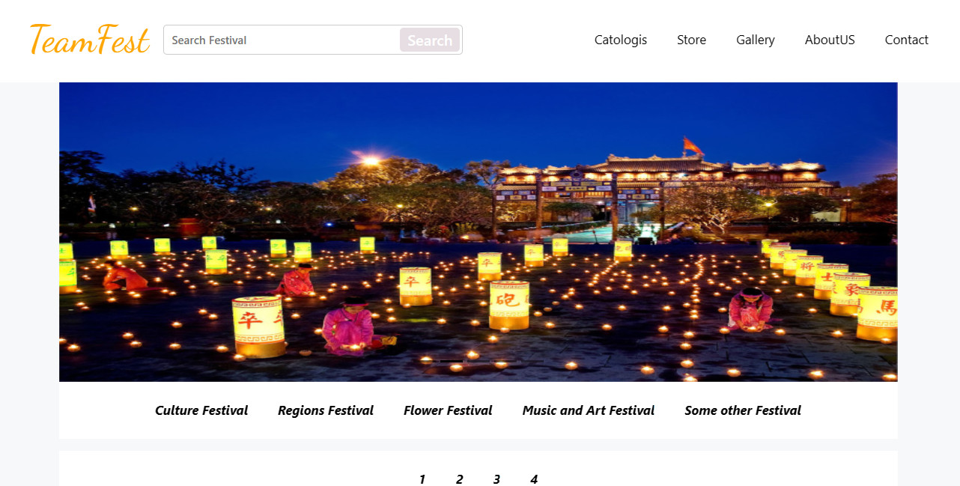

**Category Screenshot**

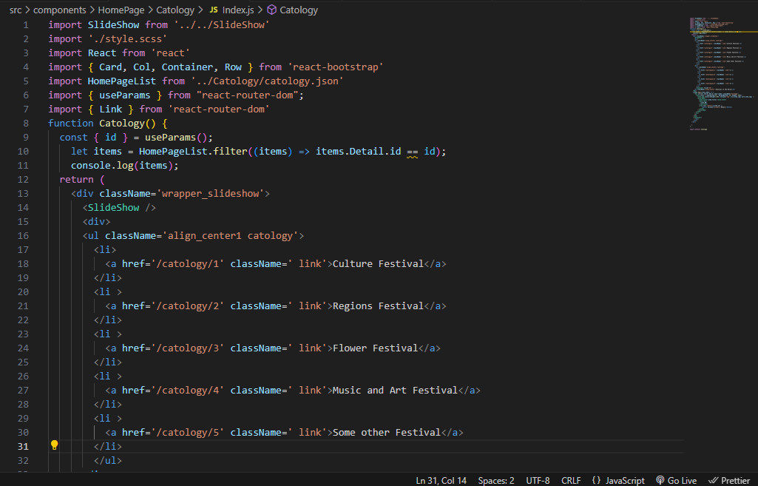

**Category code**

1. **Galleries**

The Gallery shows the pictures represent for the festival and the events occurs during the festival.

The visitors will experience the fun and joy of the festival and also understanding more about the events which will suitable for them.

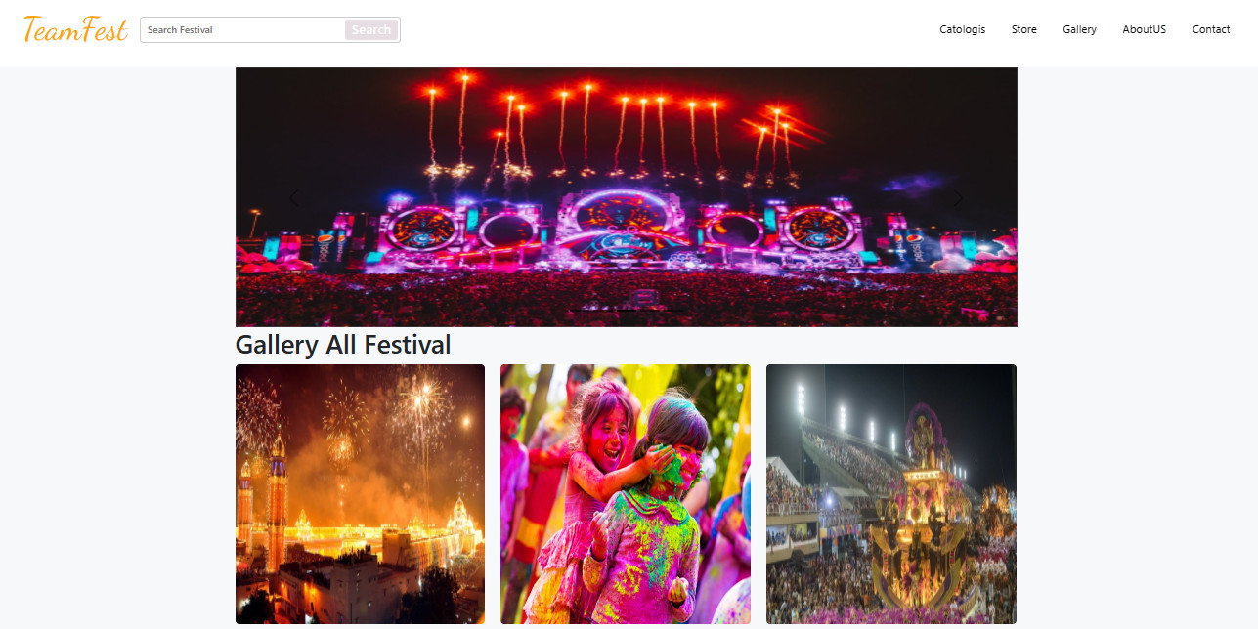

**Gallery Screenshot**

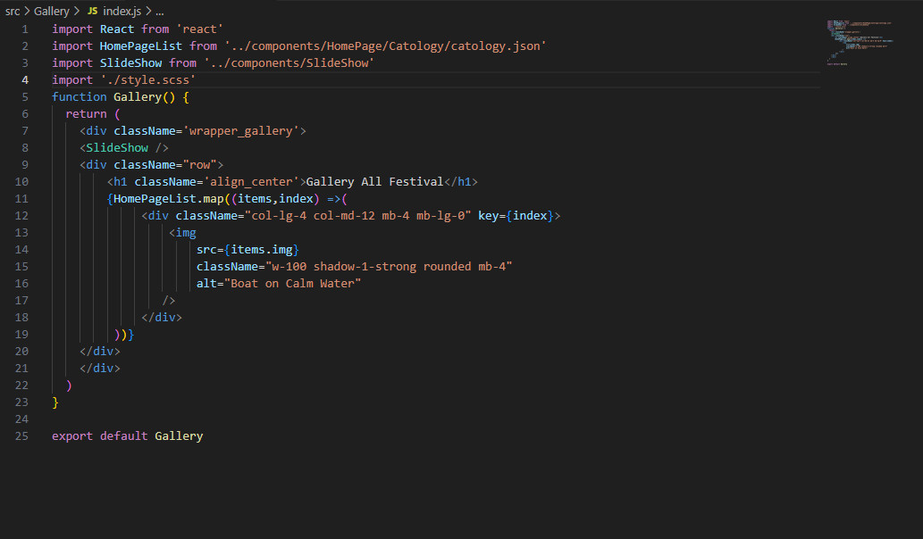

**Gallery code**

1. **Store**

The store shows the souvenirs according to the festival theme for the visitors to purchase online.

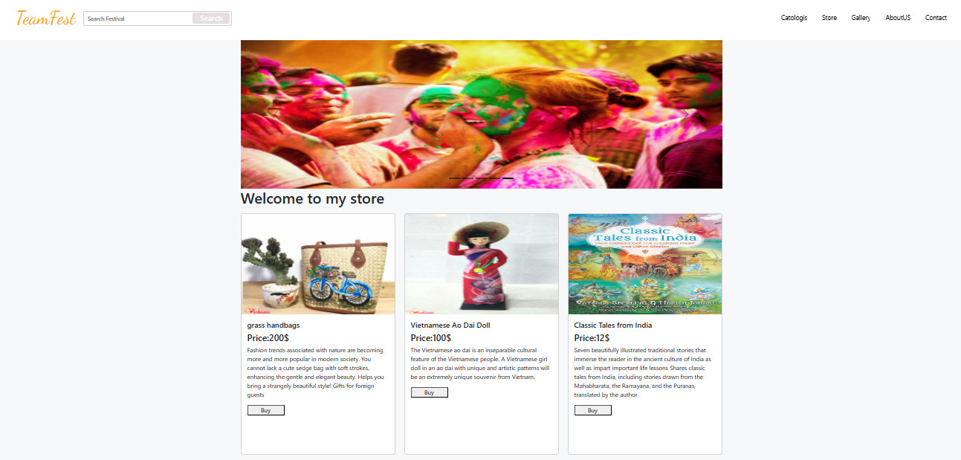

**Store screenshot**

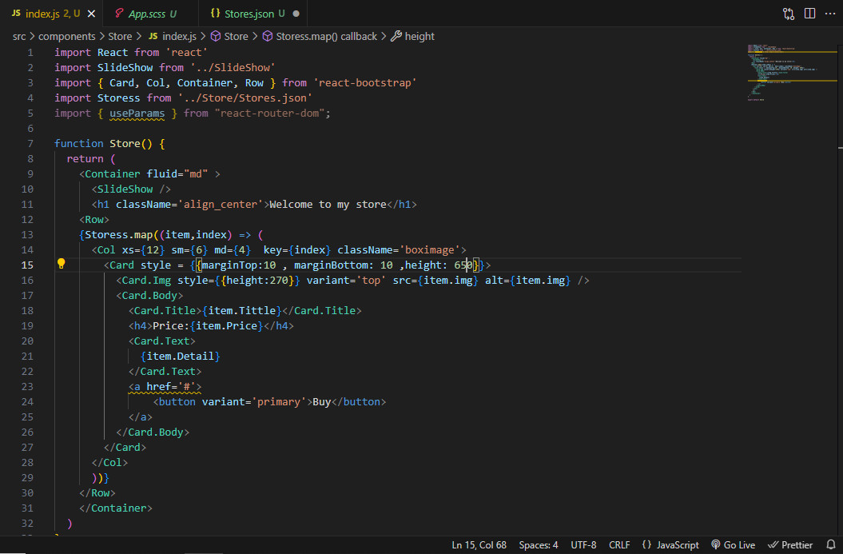

**Store Code**

1. **Contact Us**

The contact us shows the information to contact to the owner of the website. Furthermore, the visitors can also directly contact the admin by submitting the form through the website.

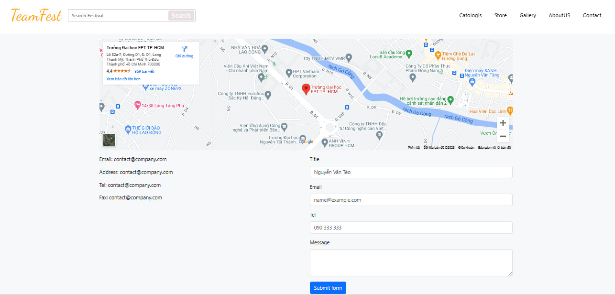

**Contact Us Screenshot**

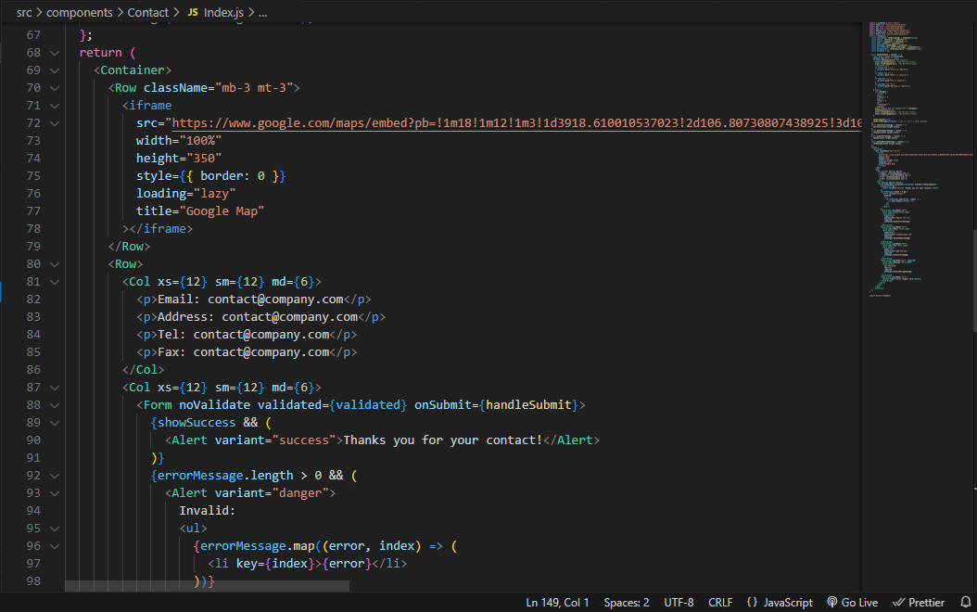

**Contact Us code**

1. **About us**

The About us shows the information about the overall objectives and the expectations of the website to the visitors and customers.

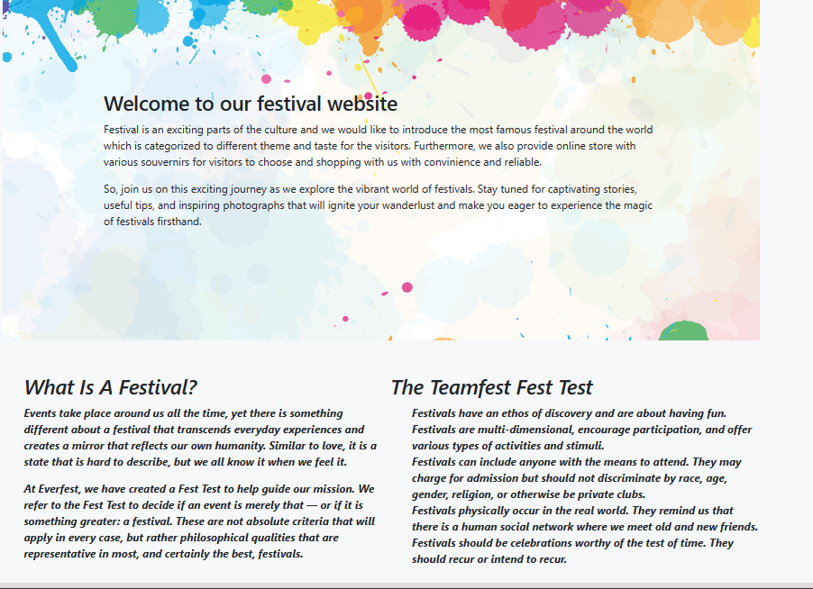

**Screenshot of About Us**

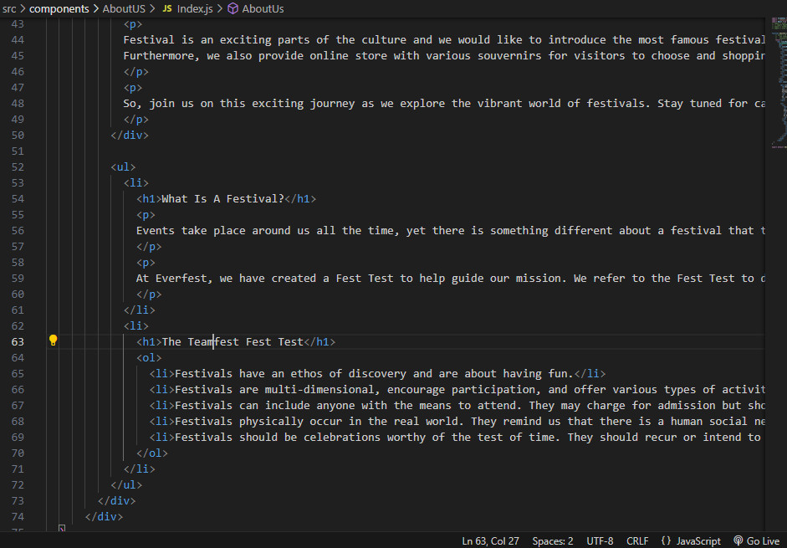

**Code of about us**

# TASK SHEET REVIEW 3

|  |  |  |  |  |  |  |  |
| --- | --- | --- | --- | --- | --- | --- | --- |
| **Project Ref. No.:**  **eP/Advertisement**  **Portal Management System/01** | | **Project Title:** | **Activity Plan Prepared By:** | **Date of Preparation of Activity Plan:** | | | |
| **Sr.**  **No.** | **Task** | **Actual**  **Start Date** | **Actual Days** | **Team**  **Mate Names** | **Status** |
| 1 | Home page | Festival | Hoang | 27-Sep-2021 | 1 | Hoang,Bao | Completed |
| 2 | Categories | 27-Sep-2021 | 1 | Minh,Bao | Completed |
| 3 | Galleries | 27-Sep-2021 | 1 | Bao | Completed |
| 4 | Store | 27-Sep-2021 | 1 | Bao | Completed |
| 5 | Contact us | 27-Sep-2021 | 1 | Minh, Bao | Completed |
| 6 | About us | 27-Sep-2021 | 1 | Hoang,Minh | Completed |
| 7 | json | 27-Sep-2021 | 1 | Minh,Bao | Completed |
| 8 | Task sheet | 30-Sep-2021 | 1 | Hoang | Completed |

|  |  |
| --- | --- |
| Date: 29/09/2023 | |
| Signature of Instructor:  **Mr. Nguyen Phat Tai** | Signature of Team Leader:  **Mr. Le Trung Hoang** |